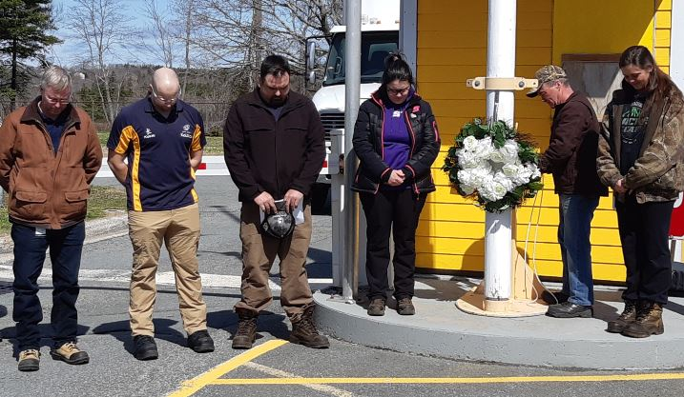
Unit 10 - These are two pictures from our Day of Mourning event held this year on April 26 at the Miller Lake Mechanical Branch. We had great weather and a great turn out for the laying of the wreath, flag lowering and moment of silence ceremonies. This year the wreath was laid by two of our young workers Sarah and Tailor with the flag being lowered by Carl also included a poem read by Tailor and speeches from both Nick and Craig. Followed by coffee and donuts in the main shop provided by the Miller Lake management team .
In the pictures from left to right is Jeff McNeille (Fleet Service Manager), Nick Munroe (Dept. HSE Specialist), Craig Bayer (Provincial Vice President), Tailor Robicheau, Carl Courtney and Sarah West

