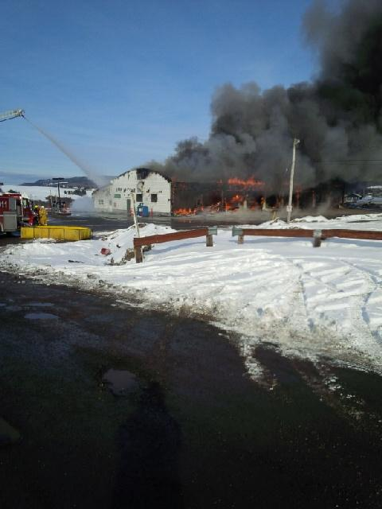
Nova Scotia Highway Workers, CUPE Local 1867, Executive Board would like to thank all our members in Unit 5 (Antigonish) for their sincere dedication and hard work and working through taxing times after a fire engulfed their 8 bay plow shed on January 21, 2014
Not only did they lose 3 pieces of winter plow equipment but facilities housing approximately 50 employees as well. Through sure determination, these individuals worked hand in hand with Managements to give their community service under such circumstances.
Thank you to all the other members across the province for getting replacement equipment ready and delivering it to Antigonish during this emergency on the eve of a blizzard.

