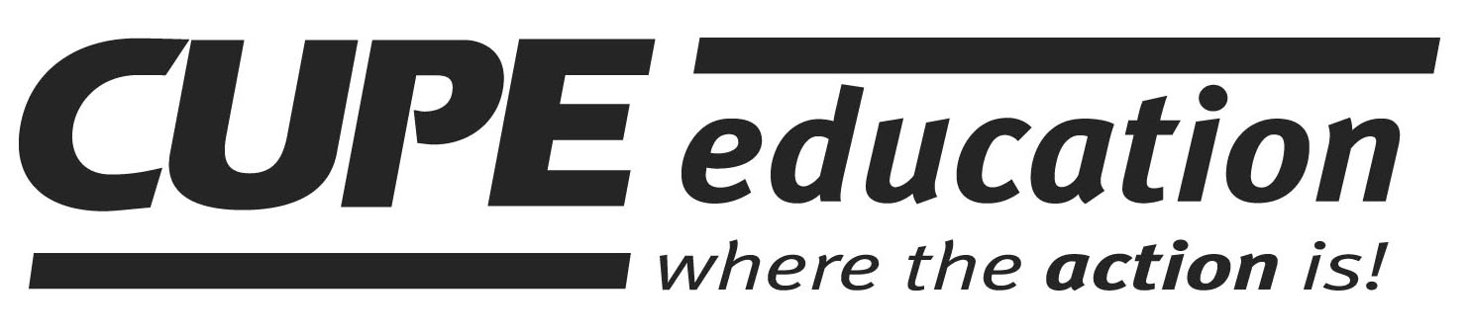
ATLANTIC REGION PRESENTS -
2015 NOVA SCOTIA FALL WORKSHOP SCHEDULE
DATE | WORKSHOP | LOCATION
September 19 – 20, 2015 | Steward Learning Series (SLS):  - Building Your Case  - Literacy Awareness for Stewards  - What Stewards Need to Know about Health & Safety | Bridgewater
September 26, 2015 | Using Our Power at Election Time (6 hrs) – Saturday only | Dartmouth
September 26 – 27, 2015 | Recording Secretaries | Sydney
October 3 – 4, 2015 | Health & Safety: an Introduction (new) | Dartmouth
October 3 – 4, 2015 | Steward Learning Series:  - Handling Grievances Without Going to Arbitration  - Creating Psychologically Healthy & Safe Workplaces (new)  - Being An Ally for Equality | New Glasgow
October 17 - 18, 2015 | Steward Learning Series:  - What Stewards Need to Know about Arbitration  - Understanding Mental Health (new)  - Creating Gender Equality | Dartmouth
October 17 - 18, 2015 | Introduction to Stewarding | Sydney
October 17 - 18, 2015 | Steward Learning Series:  - Handling Grievances Without Going to Arbitration  - Creating Psychologically Healthy & Safe Workplaces (new)  - Conflict Resolution | Yarmouth
November 21 - 22, 2015 | Duty to Accommodate | Dartmouth
November 21 - 22, 2015 | Workplace Violence | Yarmouth
November 28 - 29, 2015 | Building Strong Local Unions | Dartmouth
November 28 - 29, 2015 | Steward Learning Series:  - Conflict Resolution  - Understanding Mental Health  - Mobilizing Workers | Sydney
December 5 – 6, 2015 | Financial Officers | Dartmouth
December 5 – 6, 2015 | Workplace Stress | New Glasgow

js/cope491

